

Mark Twain School for Scholars
12800 Visger, Detroit, MI 48217
Office: 313-386-5530; Fax: 313-386-5965
Dr. Jemel M. Hence, Principal
Mrs. Jessica L. Gunter, Assistant Principal

Dress Code Where We Dress for Success!
Pre- K- 8th
Top |  |  | Bottoms
- Mark Twain T-shirts  - Shirts and blouses must have buttoned-down or straight collars.  - Turtlenecks and polo styles are permitted.  - Long and short sleeves |  |  | - Sweatpants/Jeans without holes/rips  - All slacks and pants must be a solid color. Khaki, navy blue or black  - Slacks and pants can be pleated or flat front  - Knee-length skirts and jumpers
Cardigans and Sweaters |  |  | Footwear
- Sweaters/Cardigans must be worn over a collared shirt, turtleneck or polo style shirt.  - Sweatshirts with hoods. HOODS CANNOT be worn on your head during the school day. |  |  | Athletic shoes, laced shoes and/or other shoe boots, loafers, or other closed-toed/closed-heel shoes
 | Prohibited
 |  | - Graphic clothing with drug use, sexual or violent content  - Leggings  - Slippers  - Sandals  - Bubble Slides |  | - Bonnets  - Do-Rags  - Hats/Cap  - Sweatbands  - Bandannas  - Crop tops/Sleeveless top
 |  |  |  | - Biker Shorts

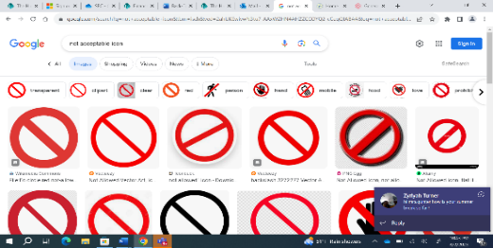

AM HOMEROOM TEACHERS SHOULD LOG DRESS CODE VIOLATIONS
1ST OFFENSE – VERBAL WARNING AND LOG THE INFRACTION
2ND OFFENSE – PARENT PHONE CALL, LOG THE INFRACTION, SEND TO THE OFFICE FOR CHANGE OF CLOTHES
3RD OFFENSE – PARENT PHONE CALL, LOG THE INFRACTION, REFERRAL TO THE ISS ROOM. (MEETING WITH ADMINISTRATOR). 3RD – 8TH ISS ONLY
K – 2ND GRADE STUDENTS PLEASE CONTINUE TO LOG, CONTACT PARENTS NO REFERRAL/ISS


Students Rise. We All Rise.

